Assignment Name: Component Hunt
Description: Break a popular website into components and sketch the structure.

1. Overall Page Structure
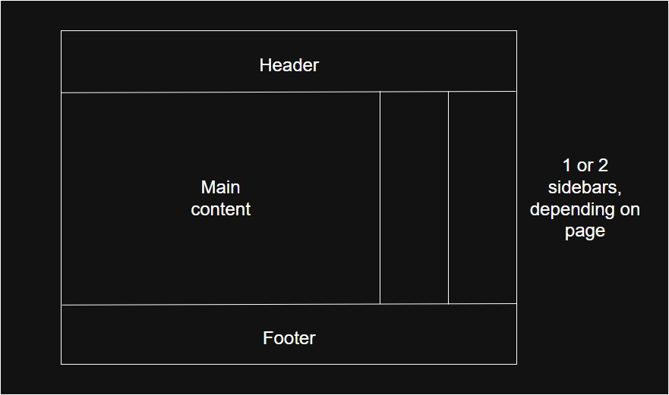
2. Component Breakdown
1. Header Component
- Logo (MDN)
- Search bar
- Navigation menu (Docs, Learn, References)
- Theme toggle (dark/light)
- User profile/login
Reusable in all pages
2. Sidebar Component
- Navigation links
- Topics list (HTML, CSS, JS)
- Collapsible sections
Helps in quick navigation
3. Main Content Component
- Article title
- Description
- Code examples
- Images/diagrams
Core part of the website
4. Right Panel (Optional Component)
- Table of contents
- Page sections
- Quick links
5. Footer Component
- Links (About, Privacy, Terms)
- Social links
- Copyright
3. Component Tree
App
├── Header
├── Sidebar
├── MainContent
│ ├── Article
│ ├── CodeBlock
│ └── Images
├── RightPanel
└── Footer

